Lab 3 — Set Up Monitoring Using Prometheus and Grafana
Shashank Sendil Kumar | Repository: github.com/shashank12004/devops-lab-3

Objective
Set up monitoring using Prometheus and visualize the metrics in Grafana dashboards. An nginx web server is the target application, and a Node Exporter container provides system metrics. Prometheus scrapes and stores the metrics, and Grafana queries Prometheus to draw dashboards. The whole stack runs with Docker Compose.

Architecture
nginx (stub_status) → nginx-exporter → Prometheus (scrape and storage) → Grafana (dashboards) Node Exporter (system metrics) → Prometheus (scrape and storage) → Grafana (dashboards)

Step 1 — Prepare the environment
Docker and Docker Compose are checked. No kernel changes are needed for this stack.
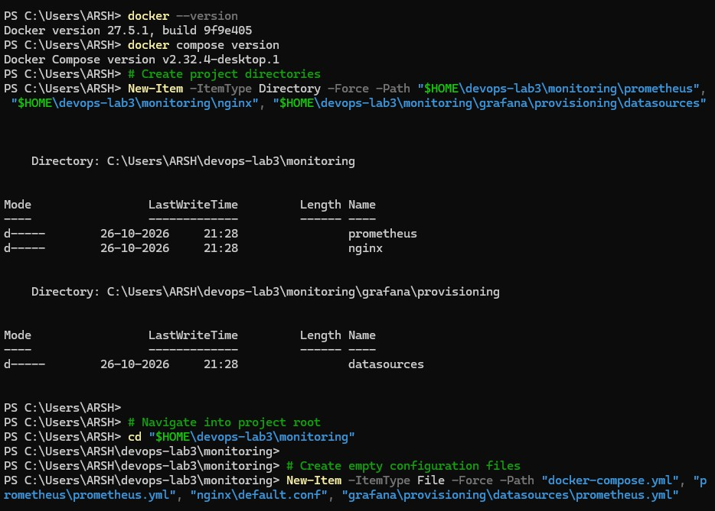
docker --version docker compose version

Figure 1 — Docker and Docker Compose installed.

Step 2 — Create the project structure
The project has a Compose file, a Prometheus configuration, an nginx configuration and a Grafana data source file.
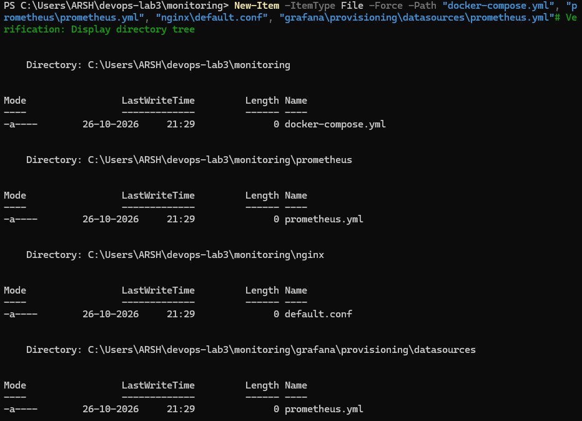
mkdir -Force ~/devops-lab3/monitoring/prometheus, ~/devops-lab3/monitoring/nginx, ~/devops-lab3/monitoring/grafana/provisioning/datasources
cd ~/devops-lab3/monitoring
New-Item docker-compose.yml, prometheus/prometheus.yml, nginx/default.conf, grafana/provisioning/datasources/prometheus.yml

Figure 2 — Monitoring project files.

Step 3 — Configure the target application (nginx)
nginx serves the default page on port 80. A second server block on port 8080 exposes the built-in stub_status page, which the exporter reads. Port 8080 is not published to the host.
server { listen 80; location / {
root /usr/share/nginx/html; index index.html;
}
}

server {

listen 8080;
location /stub_status { stub_status;
}
}
nginx/default.conf

Step 4 — Define the stack (docker-compose.yml)
Five services are defined: nginx as the target, nginx-exporter to turn stub_status into Prometheus metrics, node-exporter for system metrics, Prometheus and Grafana. Named volumes keep Prometheus and Grafana data across restarts. The Grafana admin password is set for this lab setup only.
services: nginx:
image: nginx:alpine ports:
- "8082:80"
volumes:
- ./nginx/default.conf:/etc/nginx/conf.d/default.conf:ro

nginx-exporter:
image: nginx/nginx-prometheus-exporter:1.3.0 command:
- --nginx.scrape-uri=http://nginx:8080/stub_status depends_on:
- nginx

node-exporter:
image: prom/node-exporter:v1.8.2

prometheus:
image: prom/prometheus:v2.54.1 ports:
- "9090:9090"
volumes:
- ./prometheus/prometheus.yml:/etc/prometheus/prometheus.yml:ro
- prometheus_data:/prometheus depends_on:
- nginx-exporter
- node-exporter

grafana:
image: grafana/grafana:11.2.0 ports:
- "3000:3000"
environment:
- GF_SECURITY_ADMIN_USER=admin
- GF_SECURITY_ADMIN_PASSWORD=admin
volumes:
- ./grafana/provisioning:/etc/grafana/provisioning:ro
- grafana_data:/var/lib/grafana depends_on:
- prometheus

volumes:

prometheus_data: grafana_data:

Step 5 — Configure metric collection (Prometheus)
Prometheus scrapes every 15 seconds. Three jobs are defined: Prometheus itself, Node Exporter for system metrics and the nginx exporter for application metrics. Targets are reached by their Compose service names.
global: scrape_interval: 15s
evaluation_interval: 15s

scrape_configs:
- job_name: prometheus static_configs:
  - targets: ["localhost:9090"]

- job_name: node static_configs:
  - targets: ["node-exporter:9100"]

- job_name: nginx static_configs:
  - targets: ["nginx-exporter:9113"]
prometheus/prometheus.yml

Step 6 — Connect Grafana to Prometheus
Grafana loads this file at startup and creates the Prometheus data source automatically, so no manual setup is needed in the UI.
apiVersion: 1 datasources:
- name: Prometheus type: prometheus access: proxy
url: http://prometheus:9090 isDefault: true
grafana/provisioning/datasources/prometheus.yml

Step 7 — Start the stack
All services are started in the background and their status is checked. Every container should show as running.
docker compose up -d docker compose ps

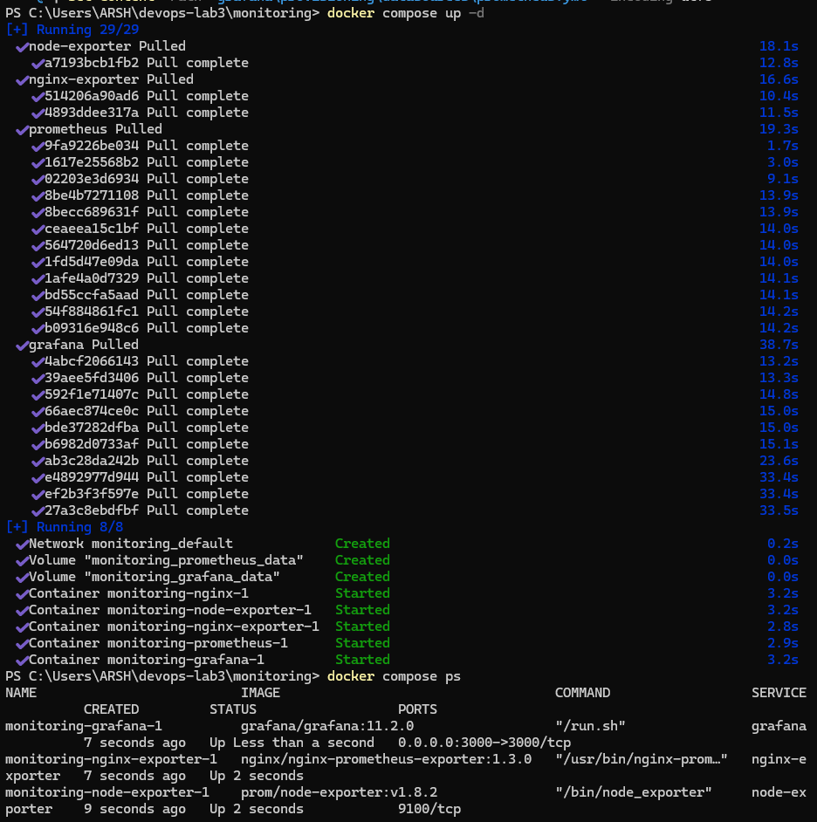
Figure 3 — Monitoring stack running.

Step 8 — Verify Prometheus targets
The Targets page at http://localhost:9090/targets lists every scrape job. All three targets should show the state UP. The same check is run from the command line through the Prometheus API.
curl.exe "http://localhost:9090/api/v1/query?query=up"

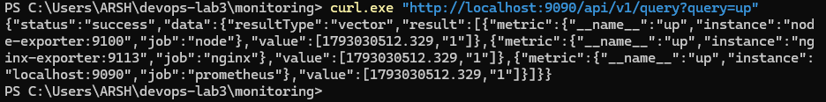
Figure 4 — Prometheus targets in the UP state.

Step 9 — Generate traffic and query metrics
Requests are sent to nginx so the application metrics change. The query nginx_http_requests_total is then run in the Prometheus expression browser to confirm the counter is increasing.
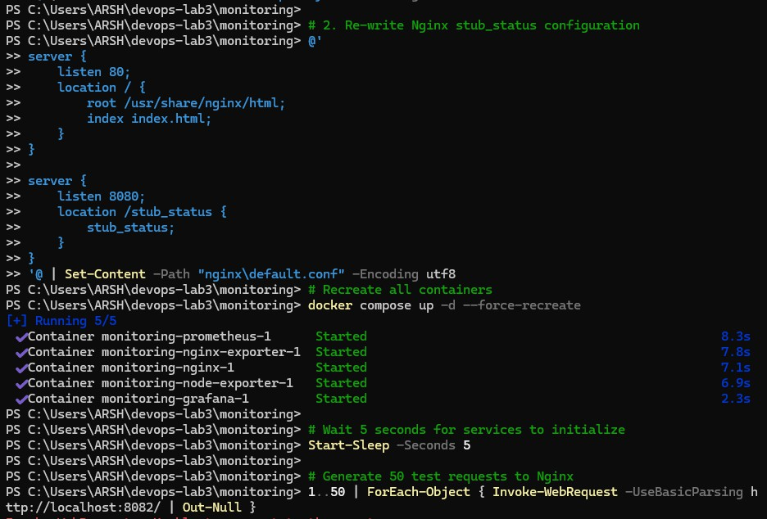
1..200 | ForEach-Object { Invoke-WebRequest -UseBasicParsing http://localhost:8082/ | Out-Null }
curl.exe http://localhost:9113/metrics

Figure 5 — PromQL query result in Prometheus.

Step 10 — Verify the Grafana data source
Grafana is opened at http://localhost:3000 and signed in with admin / admin. Under Connections > Data sources, the provisioned Prometheus data source is opened and Save & test is run. It reports that the data source is working.
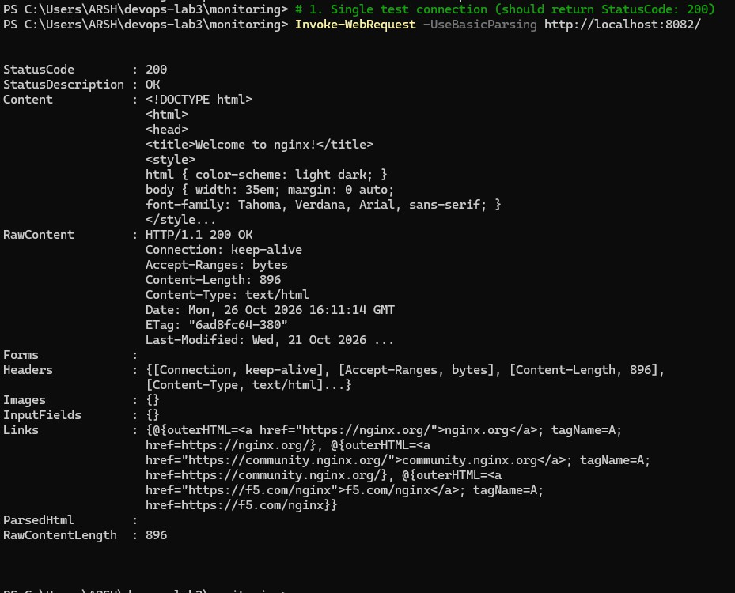

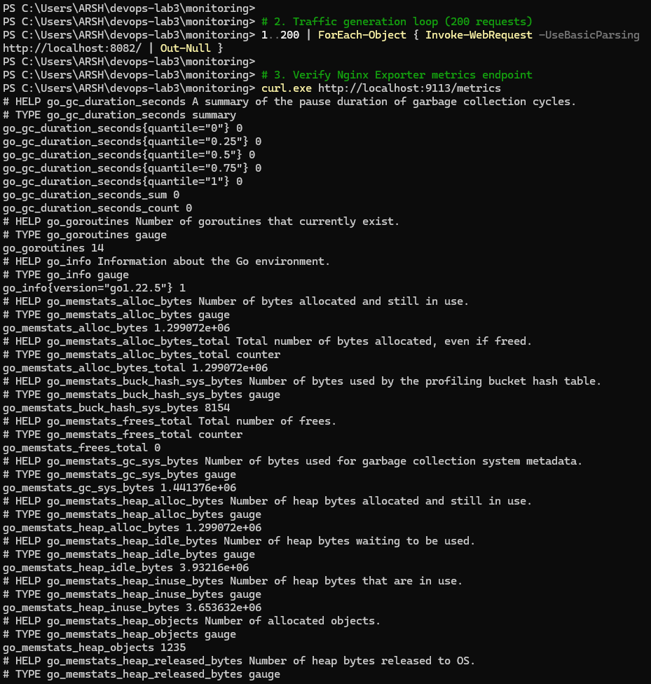

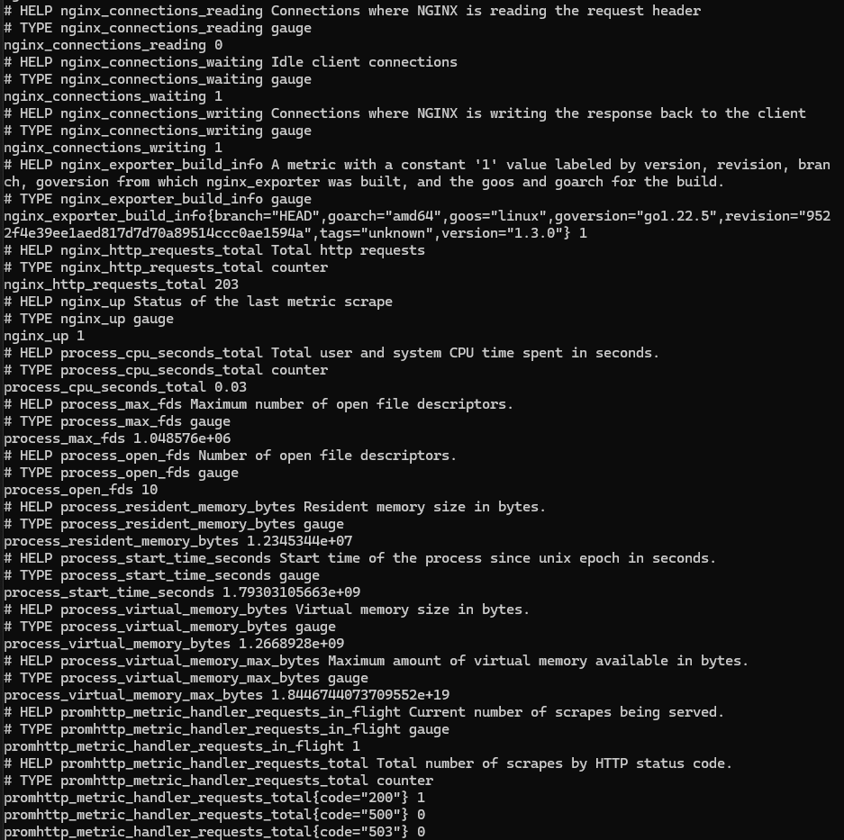
Figure 6 — Prometheus data source working in Grafana.

Step 11 — Build the dashboard
A new dashboard named "System and nginx Monitoring" is created with one panel for each query below. The data source for every panel is Prometheus. The time range is set to the last 15 minutes with a 10 second refresh.

Panel | PromQL query | Visualization
Targets up | up | Stat
CPU usage (%) | 100 -  (avg(rate(node_cpu_seconds_total{mode="idle"}[1m])) * 100) | Time series
Memory usage (%) | (1 - node_memory_MemAvailable_bytes / node_memory_MemTotal_bytes) * 100 | Gauge

Panel | PromQL query | Visualization
Disk usage (%) | 100 - (node_filesystem_avail_bytes{mountpoint="/"} / node_filesystem_size_bytes{mountpoint="/"} * 100) | Gauge
Network received | rate(node_network_receive_bytes_total{device!="lo"}[1m]) | Time series
nginx requests/sec | rate(nginx_http_requests_total[1m]) | Time series
nginx active connections | nginx_connections_active | Stat

While the dashboard is open, the traffic loop from Step 9 is run again. The nginx requests/sec panel rises, which confirms the dashboard updates from live data.

Result
The monitoring stack was deployed with Docker Compose. Prometheus scraped metrics from Node Exporter and the nginx exporter, and stored them as time series. Grafana was connected to Prometheus and displayed CPU, memory, disk, network and nginx request metrics on a live dashboard. The task is complete.

